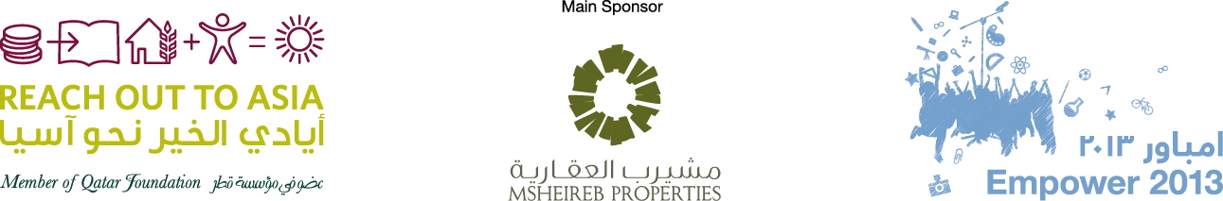

Empower 2013 Program Overview

Sessions will be a mix of Arabic and English. Translation will be provided for the sessions in the plenary
 |  | 28th March 2013 – Thursday
 |  | Time |  |  | Duration |  | Activity |  | Location
 |  | 16:30 |  |  | 90 mins |  | Registration |  | Foyer
 |  | 18:00 |  |  | 30 mins |  | Prayer break. |  | Prayer room
 |  | 18:30 |  |  | 30 mins |  | Exhibition |  | Plenary
 |  | 19:00 |  |  | 10 mins |  | Opening Ceremony led by RYAB |  | Plenary
 |  | 19:10 |  |  | 10 mins |  | Welcome Speech |  | Plenary
 |  | 19:20 |  |  | 10 mins |  | Opening Speech |  | Plenary
 |  | 19:30 |  |  | 40 mins |  | Youth power speeches |  | Plenary
 |  | 20:10 |  |  | 20 mins |  | Break |  | Plenary
 |  | 20:30 |  |  | 20 mins |  | Key Note Speech 1 |  | Plenary
 |  | 20:50 |  |  | 30 mins |  | Key Note Speech 2 |  | Plenary
 |  | 21:20 |  |  | 10 mins |  | briefing for Day 2 |  | Plenary
 |  | 21:30 |  |  |  |  | End of Day 1 |  | Plenary
 | 29th March 2012 – Friday
 | Time |  |  | Duration |  | Activity |  |  |  | Location
 | 8:00 |  |  | 60 mins |  | Registration |  |  |  | Foyer
 | 9:00 |  |  | 20 mins |  | Early Morning Briefing and ice breakers |  |  |  | Plenary
 | 9:20 |  |  | 20 mins |  | Flash Stories from around the world |  |  |  | Plenary
 | 9:40 |  |  | 20 mins |  | Coffee Break and move to workshops |  |  |  | Workshop
 | 10:00 |  |  | 90 mins |  | First Concurrent Workshops  7 concurrent workshops  1 seminar |  |  |  | Workshop
 | 11:30 |  |  | 45 mins |  | Jumaa Prayer break
 | 12:15 |  |  | 60 mins |  | Lunch and Performances |  |  |  | Plenary
 | 13:15 |  |  | 40 mins |  | Panel Discussion on UN Year of Water Cooperation and what it means to you? |  |  |  | Plenary
 | 13:55 |  |  | 20 mins |  | Q&A |  |  |  | Plenary
 | 14:15 |  |  | 10 mins |  | Move to Workshop
 | 14:25 |  |  | 90 mins |  | Second Concurrent workshops  7 concurrent workshops  1 seminar |  |  |  | Workshop
 | 15:55 |  |  | 20 mins |  | Coffee Break |  |  |  | Foyer
 | 16:15 |  |  | 10 mins |  | Flash Stories from around the world |  |  |  | Plenary
 | 16:25 |  |  | 20 mins |  | RYAB |  |  |  | Plenary
 | 16:45 |  |  | 10 mins |  | Announcement |  |  |  | Plenary
 | 16:55 |  |  |  |  | End of Day 2
30th March 2012 – Saturday

Time |  |  | Duration |  |  |  |  | Activity | Location
8:00 |  |  | 60 mins |  |  |  |  | Registration | Foyer
9:00 |  |  | 30 mins |  |  |  |  | Bus Departs | Entrance
9:30 |  |  | 3.5 hours |  |  |  |  | Service Learning Activities  9 different activities
13:00 |  |  | 30 mins |  |  |  |  | Arrival back to Conference Venue
13:30 |  |  | 30 mins |  |  |  |  | Reflection | Plenary
14:00 |  |  | 80 mins |  |  |  |  | Lunch/Prayer  Flash stories from around the world | Plenary
15:20 |  |  | 30 mins |  |  |  |  | Feedback from offsite activity | Plenary
15:50 |  |  | 30 mins |  |  |  |  | International Delegates Performances | Plenary
16:20 |  |  | 30 mins |  |  |  |  | Cultural Performances | Plenary
16:50 |  |  | 10 mins |  |  |  |  | Closing Ceremony | Plenary
17:00 |  |  |  |  |  |  |  | End of Conference

